**PROBLEM STATEMENTS**

**DASHBOARD 2**

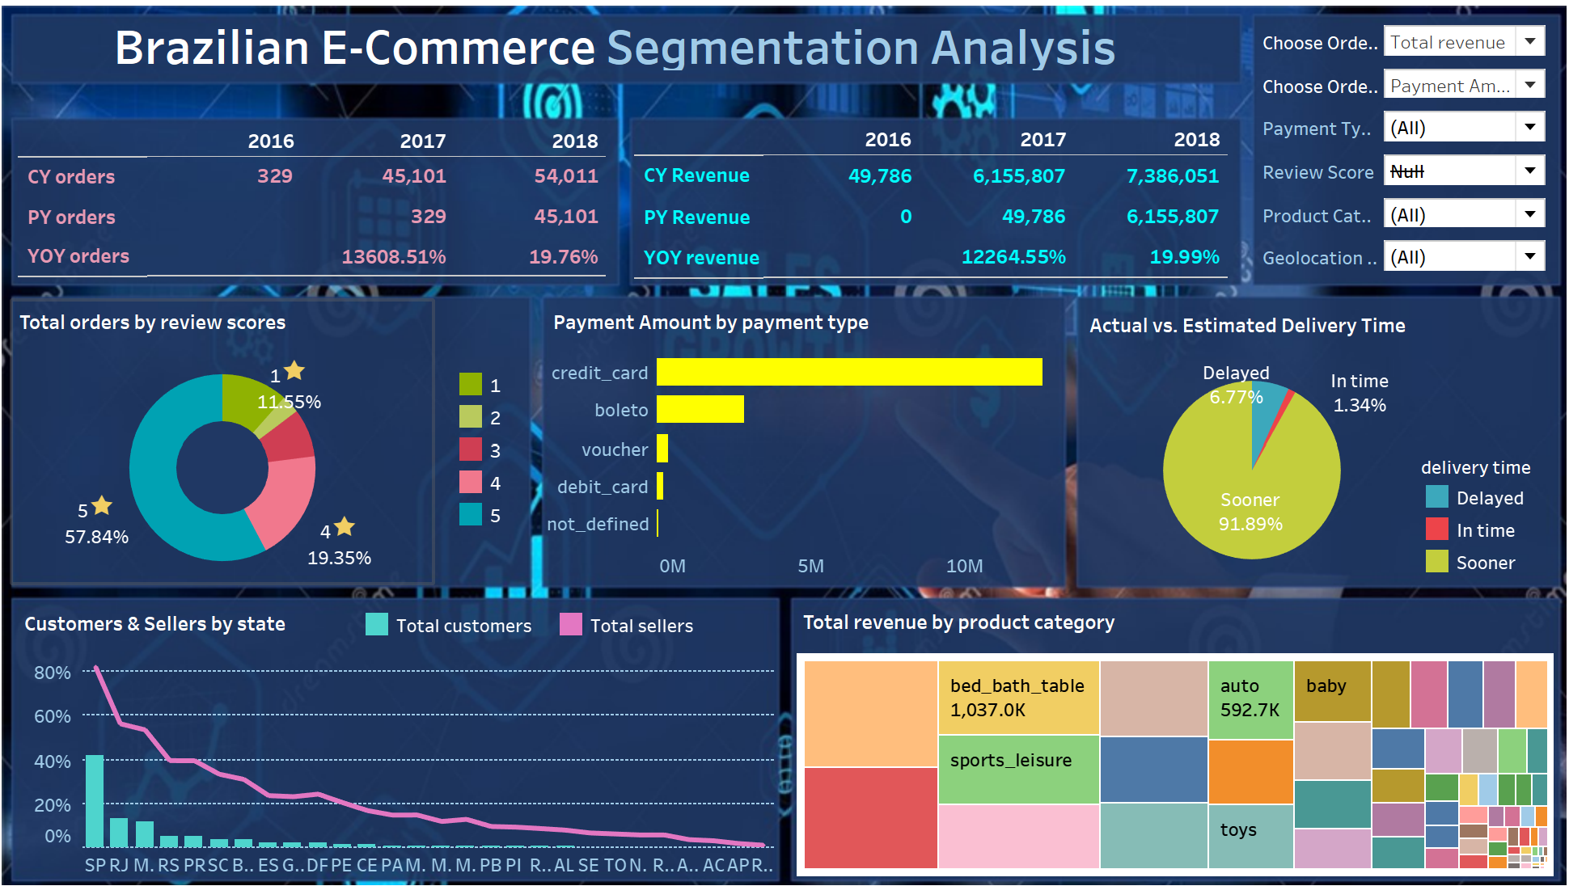

--II.1 TOTAL CUSTOMERS & SELLERS BY STATE

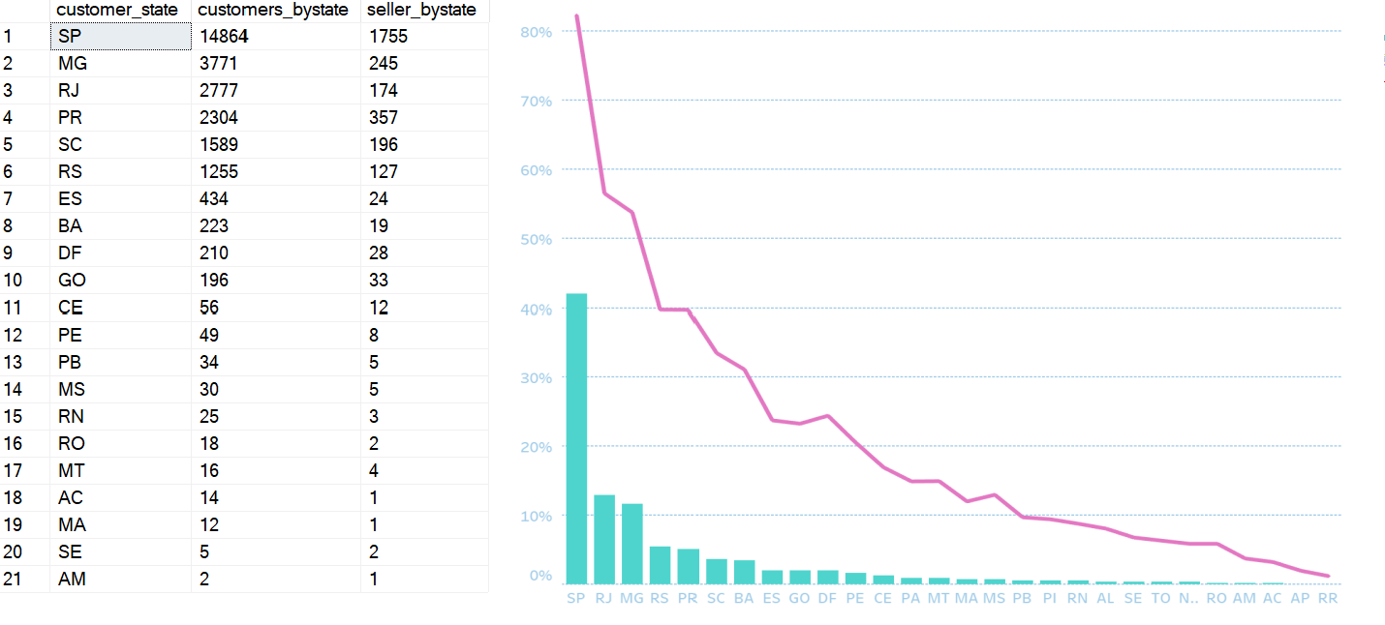

--II.2 TOTAL ORDERS/ PAYMENT AMOUNT BY PAYMENT TYPE

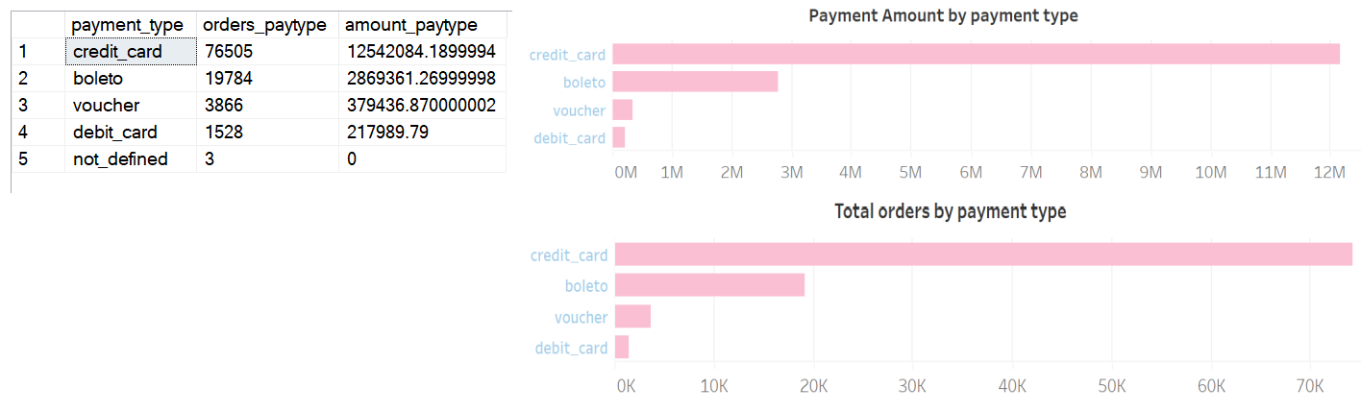

* Credit card transactions emerged as the most prevalent. Our strategic focus revolves around developing a dedicated application to facilitate seamless and unlimited bank-issued credit card payments. Collaboration with our banking partner is to not only reduce transactional costs but also to introduce attractive benefits and reward programs for customers utilizing credit card payments.
* Cash transactions also represented a significant portion. There is a consideration to enhance Cash on Delivery services, making the process more efficient and customer-friendly.
* Less common payment methods need gradually eliminated. This will reduce associated costs and simplify the payment landscape for both customers and the company.

--II.3 TOTAL ORDERS/ REVENUE BY REVIEW SCORES

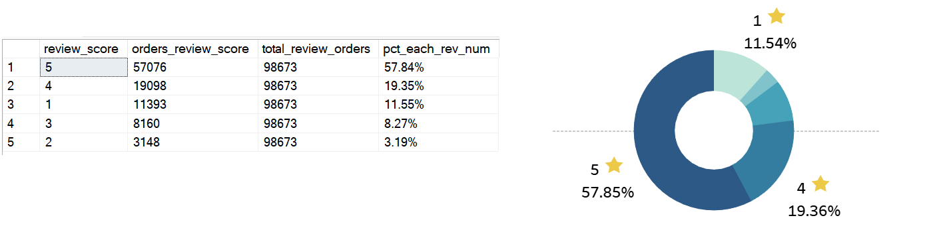

* 4-star and 5-star evaluations account for approximately 80% of the total. This is a positive indication of customer satisfaction. However, a closer look is warranted to understand the specific reasons behind 4-star evaluations. Identifying these factors will enable us to implement targeted strategies to elevate all ratings to the highest level, ensuring consistently exceptional customer experiences.
* A considerable number of orders are receiving 1-star ratings. It is necessary a thorough examination of customer service, delivery processes, product quality, and interactions with suppliers. Addressing issues related to inaccurate product descriptions, flawed return policies, and disrespectful employee attitudes is crucial to improve overall customer satisfaction.

--II.4 TOTAL ORDERS/ REVENUE BY PRODUCT CATEGORY

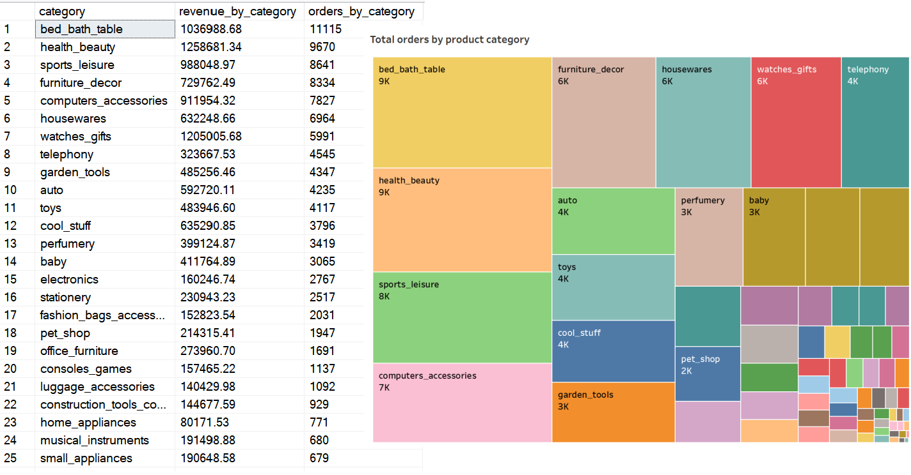

* An in-depth analysis reveals that customer preferences are concentrated on specific product categories. Understanding these preferences is crucial for optimizing the platform and creating an environment conducive to suppliers specializing in these favored products. Insights into customer buying behavior within these categories will guide targeted marketing efforts.
* With limited-purchase products on the e-commerce platform, an evaluation involves identifying reasons for limited sales, gauging market demand, and exploring avenues for improvement. By understanding the challenges these products face, we can implement strategies to boost their visibility and appeal.

--III.7 COUNT THE NUMBER ORDERS THAT WERE DELIVERED FASTER, IN TIME, SLOWER THAN ESTIMATED TIME

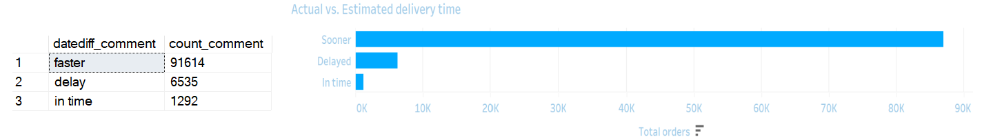

* A substantial portion of orders is consistently experiencing delays beyond the initially projected delivery dates. To identify the underlying causes of late deliveries, key areas of focus included order processing, logistics, transportation, and potential bottlenecks within the delivery chain.
* Several improvement strategies are recommended:
  + Streamlining order processing workflows to reduce internal processing time.
  + Enhancing logistics and transportation coordination for optimized route planning.
  + Implementing real-time tracking systems to identify and address delays promptly.
  + Conducting regular performance reviews and implementing key performance indicators (KPIs) for the delivery service provider.